|  |
| --- |
| Bahrain Polytechnic |
| Unix Systems |
| Lab Session 2 |
|  |
|  |
|  |

|  |
| --- |
|  |

# Lab session 2 – Introduction to Command Line Interface

## Introduction

The lab work consists of a instructional material which is designed to get you familiar with the software you will be using in the Unix systems course. Additionally, there will be some practical tasks which will require you to upload a file to Moodle once complete.

You must submit the following to the correct area in Moodle:

* A zip file named ‘lab02_*studentID*’ containing files lab2_q2.txt and lab2_q5.txt

Note: we will use psftp to retrieve the files from the student server to your windows machine.

### **Learning Outcomes Assessed**

The following learning outcomes are being assessed in this lab session:

* Use the command-line on a UNIX system
* Manage a Linux server system (including files, processes, users)

## Lab 2

Throughout many of your labs you will log into the Linux system through a Windows session. You will use two pieces of software for this; PuTTY and Remote Desktop. PuTTY will take you into a command line interface (CLI) whereas Remote Desktop will take you into a GUI set-up, known as Gnome desktop. It is possible to view both sessions at the same time. In fact, for some labs you will be required to run both sessions at the same time.

This lab will concentrate of using PuTTY. Remote Desktop will be used later.

## Lab 2 – Getting started in PuTTY

Locate the PuTTY application on your computer. You can do a search if you don’t know what it looks like. The icon is:

Launch the application and complete the setting as below:

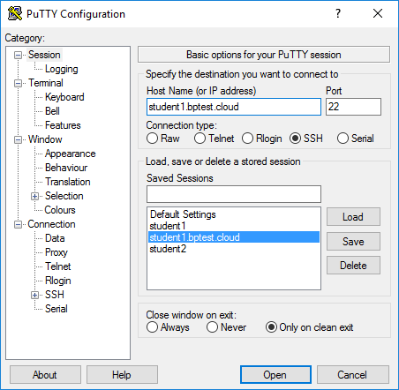

1.

Host name: student1.bptest.cloud

Port: 22

3. Finally, click ‘Open’ and you will be connected to the unix server.

2. You will be using this often. It is recommended you save the setting for future use. Click ‘Save’ and enter a name for the saved settings.

Once you are into the Unix session you will be faced with a window like below:

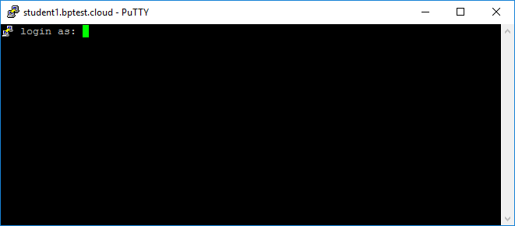

Enter you username and then password:

Username: A20XXXXXX  where XXXXX is the student number (remember, it is case sensitive)

Password: *Enter your password.*

If you have not changed your password, the default is ‘polytechnic’. If you are logging in for the first time use the *passwd* command to change your password.

Your screen should look like:

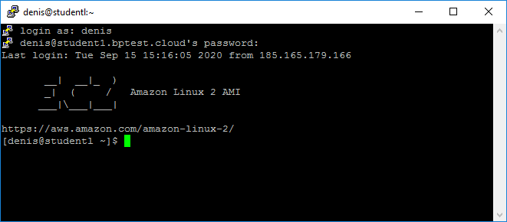

To get the screen above change the window settings in PuTTY before you log in to 120x20.

You are now ready to start entering commands, enjoy!

## Lab 2 – Basic Unix commands

The command line interface (sometimes called a terminal) allows you to enter text commands to the Linux kernel and run programs. This terminal window is controlled by the program **bash**. When Googling for help about a command, it might be of value to add **bash** in the search string.

If you are ever unsure about what a command does, the ‘**man**’ command will give you some help (it is short for manual). E.g. **man ls** you can also try **ls - -help .**

Using the Unix commands cheat sheet (available on Moodle), find out the correct commands to complete the following tasks:

1. a. Create a new directory named ‘lab2’ in the path /home/*studentID*

**pwd (to see current directory)**

**mkdir lab2 (to create the directory)**

**ls -l (to confirm that the directory is created (it should appear in blue))**

b. Change your directory to this new folder

**cd lab2 (to change directory to lab2)**

1. a. You are now located in the lab2 directory. Create a file named file1.txt. Create another file named file2 (without the .txt). Use the **ls** command to check your work.

Whats the difference between the two files?

**Touch file1.txt (to create empty file with that name)**

**Ls (to see that file is created)**

**Touch file2**

**Ls**

**Difference: file1.txt has an extension which is .txt but the other one doesn’t, so if when u try to open file2 the program/OS will ask you which software should be used to open the file but the first one will open in a text software like notepad.**

b. List the standard files and directories in the lab2 directory in a long format (i.e. includes date and time).

**Ls -l**

c. List ALL files in the lab2 directory in the long format. What do you see that’s different to the

output from part b.

**Ls -al**

**Difference: Al shows all files and folders even hidden ones.**

d. Repeat step ‘c’ but this time redirect the output to a file named ‘lab2_q2.txt’

Note: the redirect character is **>** ( the same as in Windows ) . To redirect the output of a command X to file Y , you would enter X **>** Y .

**Ls -all > lab2_q2.txt**

**More lab2_q2.txt (to see if the data appears).**

1. a. Change to the /home directory

**cd ~ or cd /home**

b. List the standard files and directories in the current directory in a long format (i.e. includes date and time)

**ls -l**

c. List ALL files in the current directory in the long format

**ls -all**

d. Repeat step ‘c’ but this time redirect the output to a file named ‘lab2_q3.txt’

Note: the redirect character is **>** ( the same as in Windows ) . To redirect the output of a command X to file Y , you would enter X **>** Y .

**Ls -all > lab2_q3.txt**

**Ls**

**More lab2_q3.txt**

Discussion: Can you think of a way to complete part 3 while remaining in your lab2 directory?

ls -all ~/ > lab2_q3.txt

more lab2_q3.txt

1. a. Display your current working directory

**pwd**

b. Try to enter the directory of a fellow student – can you ?

**all accounts of all users on this server is under the home directory (/home)**

**cd /home**

**ls -l (you will see all users)**

**you cant enter another users account**

- What do you notice about the permissions of the directories?

c. Change your directory back to /home/*yourstudentID*/l*ab2*

**cd ~/lab2 or cd /home/ID/lab2**

1. a. Type the following command: **echo unix is great!** and redirect it to a file named ‘lab2_q5.txt’. This file should now be located in /home/*studentID*/lab2.

Note: the redirect character is **>** ( the same as in Windows ) . To redirect the output of a command X to file Y , you would enter X **>** Y .

**Echo unix is great! > lab2_q5.txt**

b. Confirm that the file has been created using the appropriate command and append the output of this command to the lab2_q5.txt file.

Note: the append character is **>>** . To append the output of a command X to file Y that already exists , you would enter X **>>** Y .

**ls -l >> lab2_q5.txt (we used >> in order to just add text and prevent unix from removing any previous texts)**

**more lab2_q5.txt**

Verify your work : Inside your text document should be what is shown below:

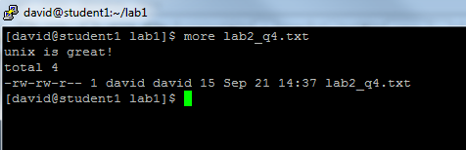

1. Retrieve the lab2_q2.txt, lab2_q3.txt, lab2_q5.txt files from the unix server using FTP. The instructions on doing this can be found at the end of this lab.

**Open psftp**

**Open student2.bptest.cloud**

**A202201043**

**041112253**

**Lcd C:\Users\USER\Documents**

**Get lab2/lab2_q2.txt Get lab2/lab2_q3.txt Get lab2/lab2_q5.txt**

**OR** **get /home/A202201043/lab2/lab2_q2.txt get /home/A202201043/lab2/lab2_q3.txt get /home/A202201043/lab2/lab2_q5.txt**

## Lab 2 – What you need to submit

* Retrieve the files lab2_q2.txt, lab2_q3.txt, lab2_q5.txt
* Zip them in a file named lab02_studentID

**Select all files**

**Send to**

**Compressed zipped folder**

* Upload it to the lab 2 file upload area in Moodle.

Connect to Moodle using the standard web browser (<http://www.tinyurl.com/moodlepoly>) or (<http://webdev.polytechnic.bh/moodle>)

## Retrieving files using SFTP

SFTP (Secure File Transfer Protocol) is an application which will allow you to retrieive files which you have created on the unix server.

*****For mac users you can transfer files directly from terminal. See the steps at the end of this lab.

1. Download PSFTP from the following website,

<https://www.puttygen.com/download-putty#PuTTY_for_windows>

Once the page is open, scroll down until use see the following screen. Click on the appropriate link for your system, psftp.exe for 32 or 64 bit.

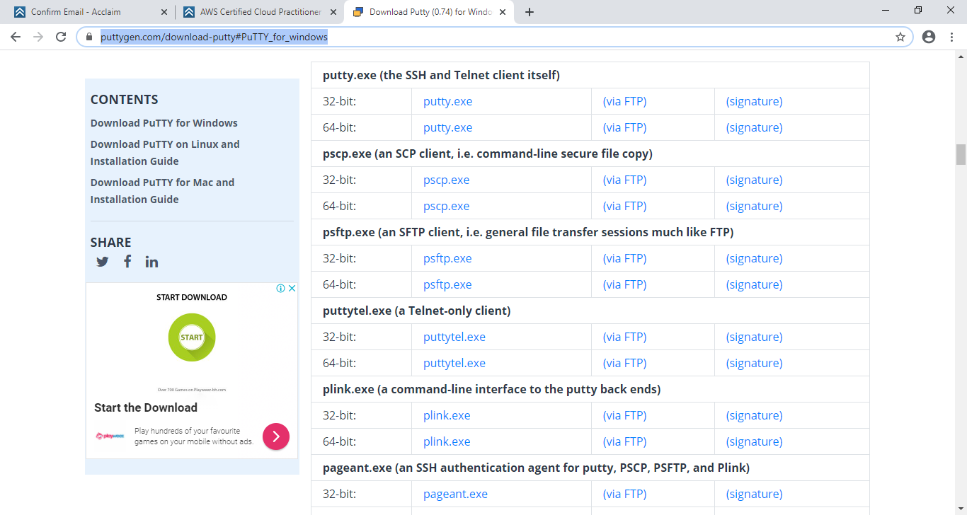

1. Launch the PSFTP application 

You can type PSFTP at the windows search.

1. Type the following commands to retrieve your files. Note:- A SFTP cheat sheet is available on Moodle which details other commands.

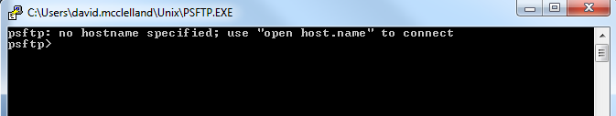

1. Type **open student1.bptest.cloud ( or student2.bptest.cloud depending what server you are working on)**
2. You will be asked for a login as and password. These are the same as your PuTTY login.
3. You now need to set up a folder location which will receive any files you ftp across from the server. You can use any folder to do this. E.g. If I want the “Documents” folder to be set as the folder that will receive files I do the following:
   1. Right click on the “Documents” folder and click properties. This will bring up the following window. Click on the location tab.

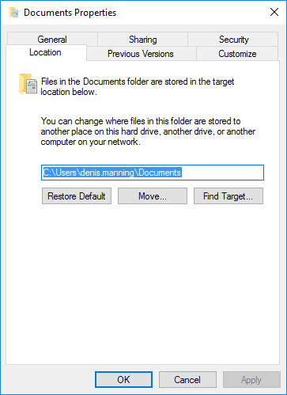

Type the command **lcd** at the psftp prompt. Do not press Enter yet.

Copy the location of the documents folder (Ctrl + C). Go back to psftp and paste(Right click) after the lcd command so that your command looks like the following:

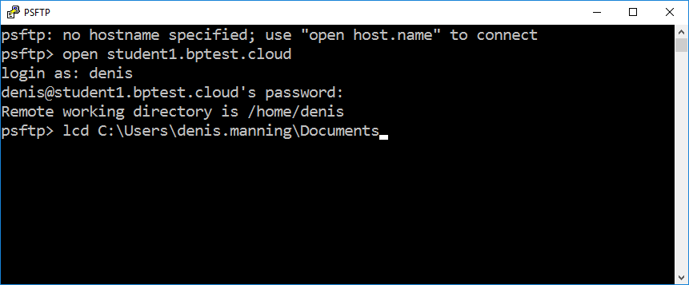

Press return and you should get the following success message:

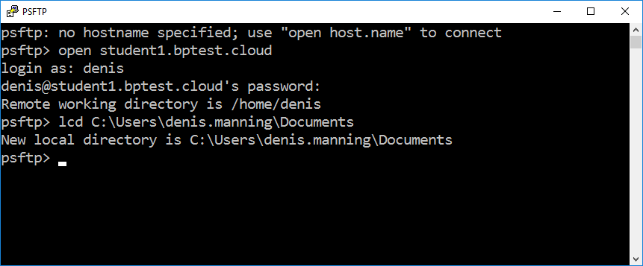

1. Any files you FTP across will now be located in **C:\Users\denis.mannning\Documents**. If you did not use the **lcd** command then all files will be dropped into the same directory as where the PSFTP is located.
2. Type **get /home/*studentID*/lab2/lab2_q2.txt** *\*\*\*This assumes your file is in this directory*
3. Type **get /home/*studentID*/lab2/lab2_q5.txt** *\*\*\*This assumes your file is in this directory*
4. If you have executed the command correctly, the files lab2_q2.txt and lab2_q5.txt should now be available in **C:\Users\denis.mannning\Documents**

## Retrieving files on a Mac

1 . Run terminal on your Mac PC.

2. Run the command ‘pwd’. The result of this command is your local path. Replace localpath in the command below with the output of this command.

3. Run this command in your terminal window. Where username is a capital ‘A’ followed by your student id. Replace every instance of username in this command with your username. Notice there is a space after lab2_q2.txt:

scp username@student2.bptest.cloud:/home/username/lab2/lab2_q2.txt localpath/Desktop

This will place your file on your Mac’s desktop. Run the command again changing the part that says lab2_q2.txt to lab2_q5.txt